[](https://tver.apsheronsk-oms.ru/tinybrowser/fulls/images/novosti/2023/10/x388zotkios.jpg)

[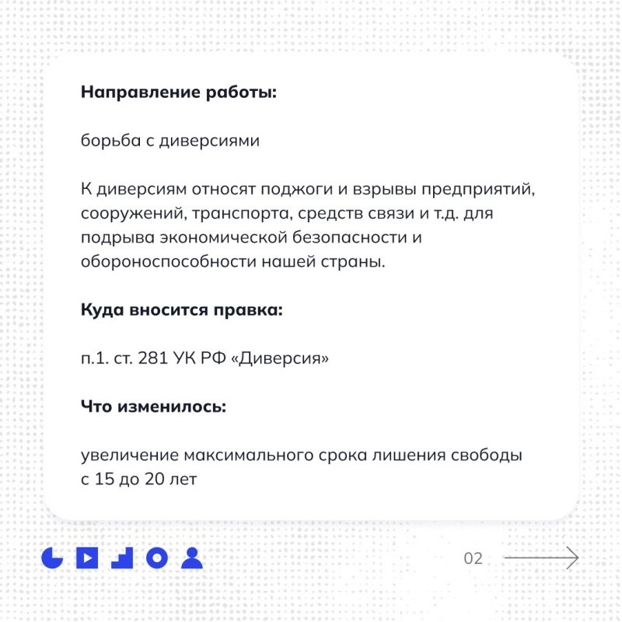](https://tver.apsheronsk-oms.ru/tinybrowser/fulls/images/novosti/2023/10/kdlvaiqzj48.jpg)

[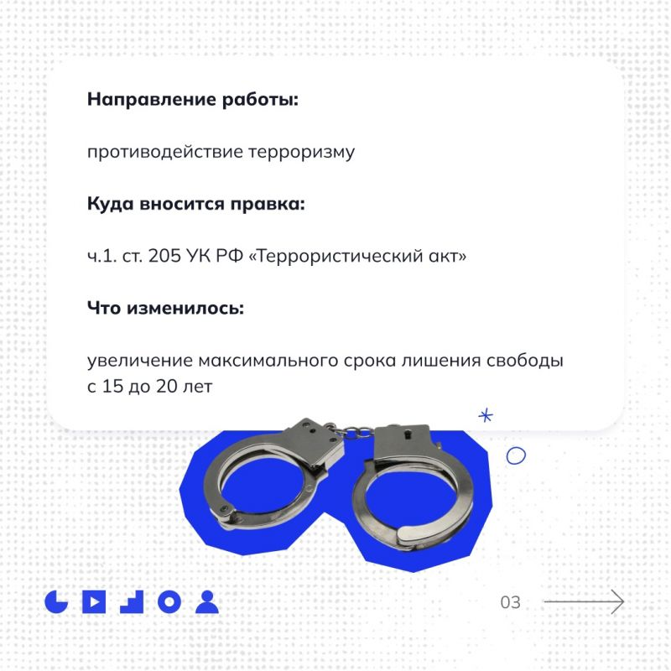](https://tver.apsheronsk-oms.ru/tinybrowser/fulls/images/novosti/2023/10/gwrqrh0nfne.jpg)

[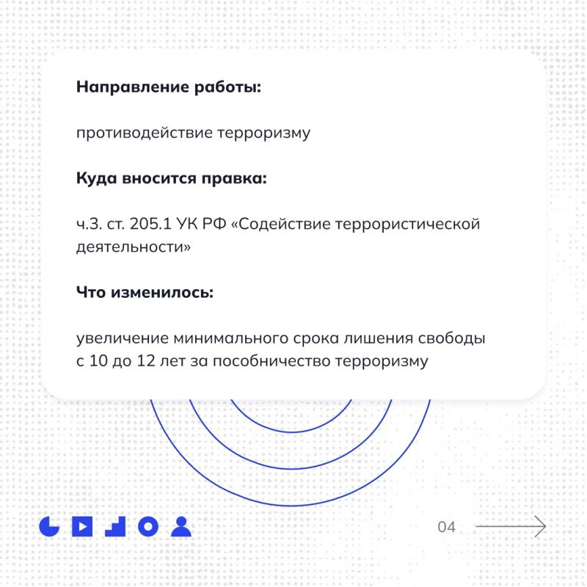](https://tver.apsheronsk-oms.ru/tinybrowser/fulls/images/novosti/2023/10/yujh2dbl2fw.jpg)

[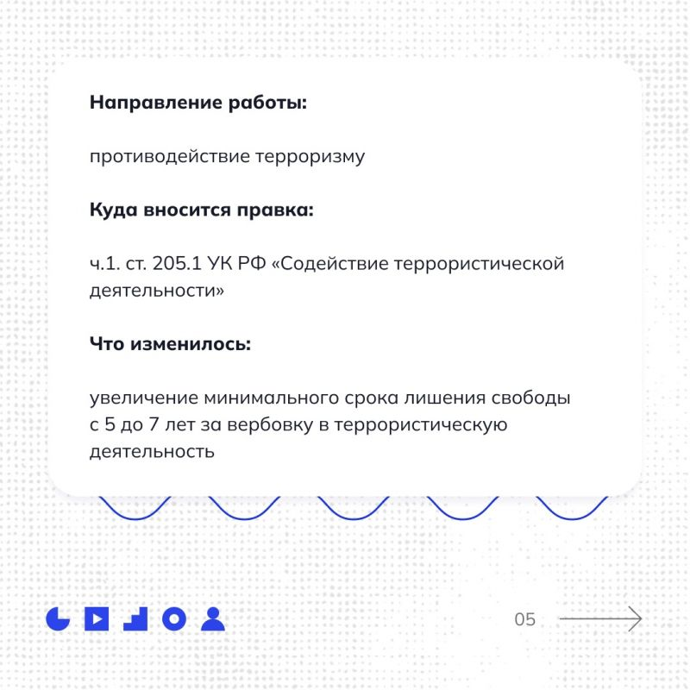](https://tver.apsheronsk-oms.ru/tinybrowser/fulls/images/novosti/2023/10/eiixlpgq1u4.jpg)

[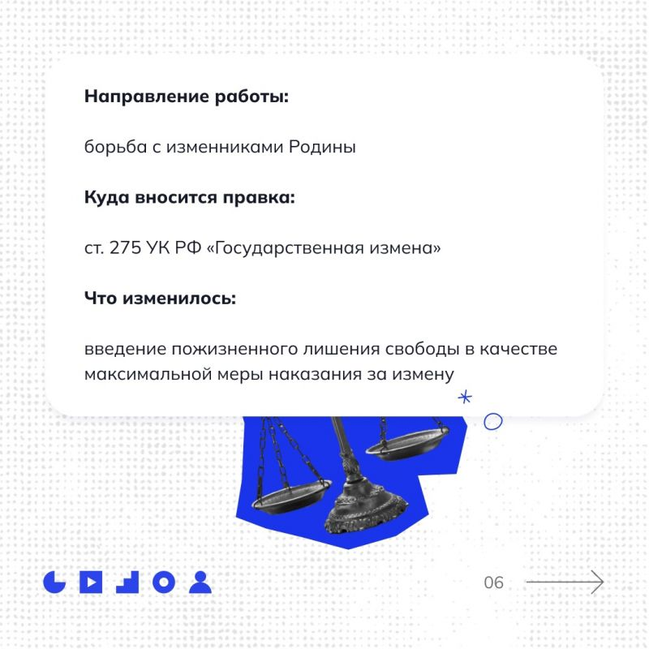](https://tver.apsheronsk-oms.ru/tinybrowser/fulls/images/novosti/2023/10/g8a6r8lqcf0.jpg)

[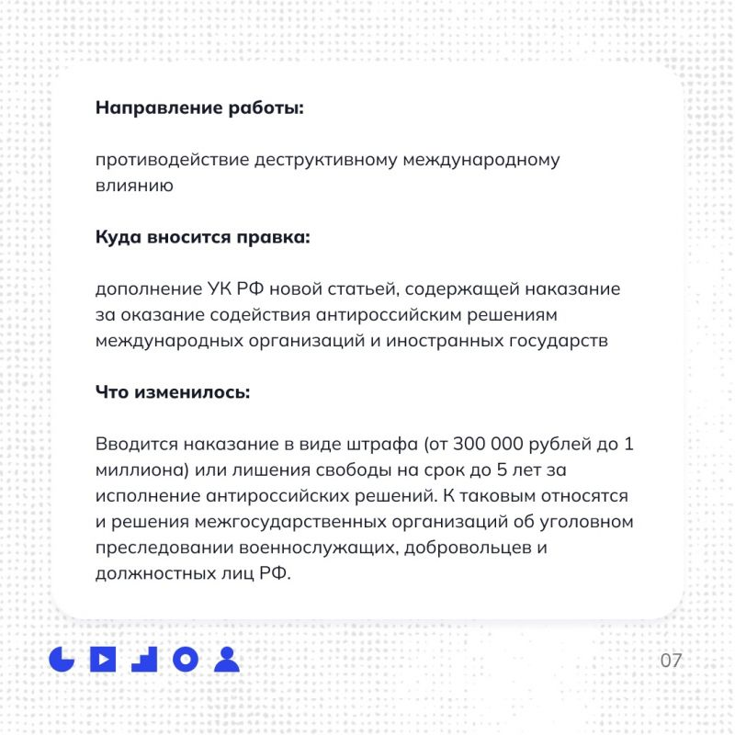](https://tver.apsheronsk-oms.ru/tinybrowser/fulls/images/novosti/2023/10/hk-bc9wex7u.jpg)